# Name : Romany adel Mansour iskander B.N: 357

**Date :**

**Topic: computer architecture Github link :**

**Github page :**

**Application brief :**

**computer architecture explains the internal and external structure of a computer, how it enters and exits data, and how it is processed. It is a design and architecture for functional processes for a computer system. Computer architecture is the job description of the requirements, design and applications of different computer parts - it mainly focuses on how the CPU performs internally its functions and how it communicates with memory addresses in the computer memory.**

**Screeshots :**



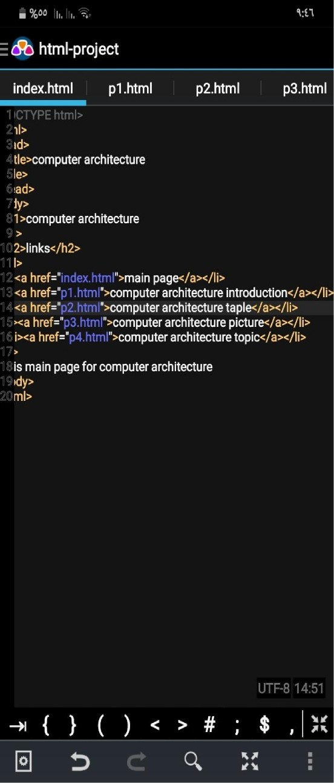computer architecture

links

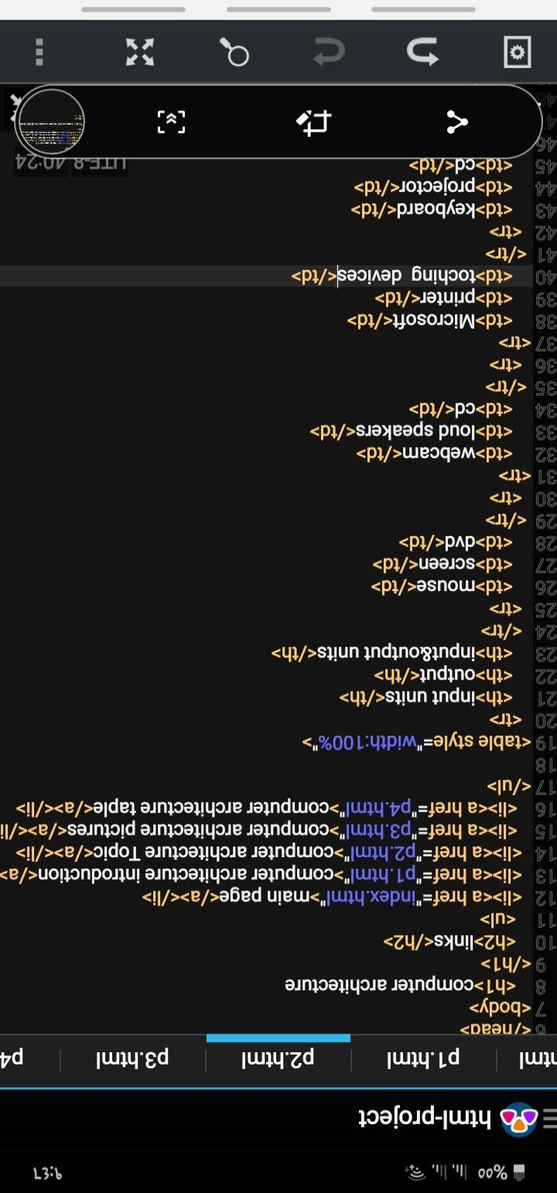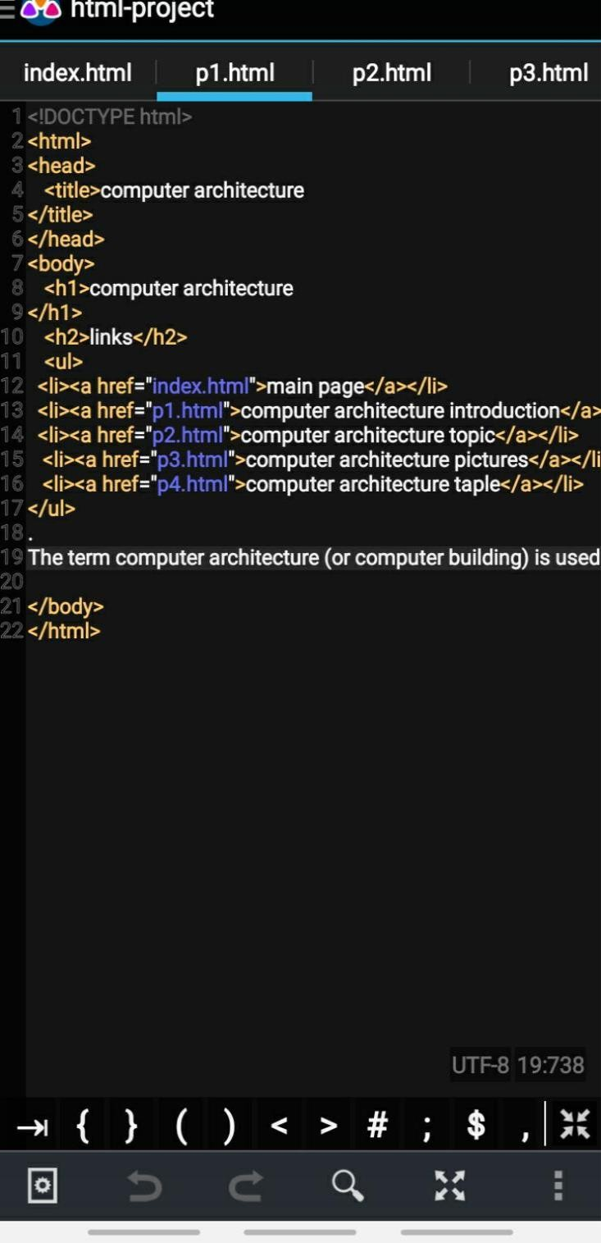

 db html-project

p1.html p2.html p3.html p4.html dD html-project



## <htmI»

### <head»

<titIe>computer architecture

</title»

## </head»

<body»

<h1»computer architecture

### «/h1»

«h2»Iinks</h2»

p1.html p2.html p3.html p4.html

<htmI»

<head»

•titIe»computer architecture

</title»

«/head»

<body»

<h1»computer architecture

<Ul> </h1»

<Ii»<a href=" "»main page</a»</lit <h2»Iinks</h2»

«Ii»<a href=" “>computer architecture introductions/ <ui»

<Ii»<a href=" ">computer architeclure 1opic</a»</li> «Ii»«a href=” “»main page«/a»</li»

<Ii><a href=’ ”>computer architecture picture</a»</li <Ii»<a href=“ "»computer architecture introductions/a>

<Ii»<a href=“ "•computer architecture taple</a»</li: <Ii»<a href=" “»computer architecture topic</a»</Ii>

</uI» ‹Ii•<a href=” "»computer architecture picture</a»</li» The computer consists of three main parts <Ii»<a href=" "»computer architecture tapIe</a»</li» Which : </uI»

.Memory 1 <img src=” I ” alt=" "»

.Input / output Ports

Central Processing Unit (CPU).

Memory: Where programs are slored to implement, data to b‹ </body>

* main sectionsTypes of memory ^/html^
* the main memory
* the secondary memory 0 Unit entry:)

Through which programs are entered and different Types of

Bus:

These units are linked together inside the computer Using thr

* bus add
* Con1roI bus

### Digital logic

I1 uses The binary counting system has only two numbers wh The slot represents the number zero, or vice versa, and can b‹

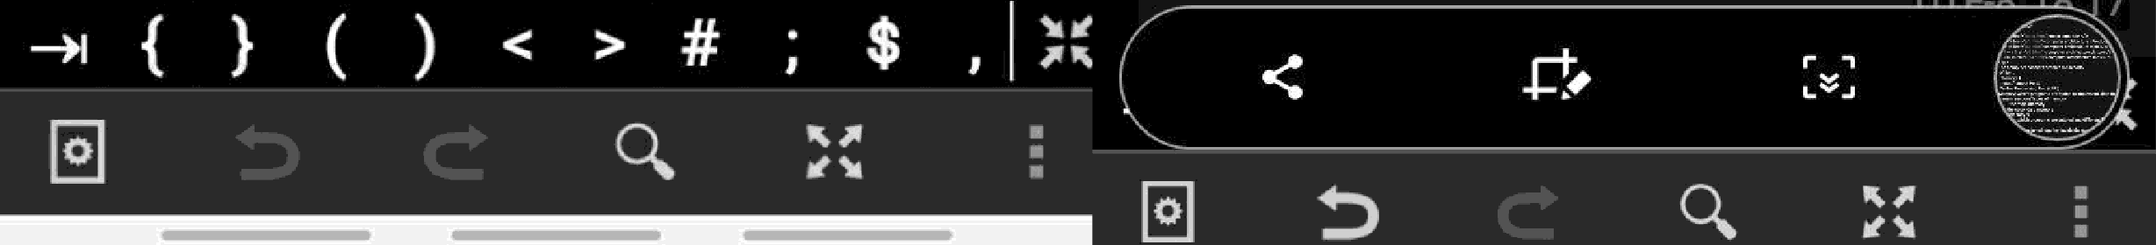

</body>

</htmI>



